**Mechatronics Assignment-2 – Position Control**

**1. This week, find a computer where you can run Matlab and Simulink----------Installed the Matlab and Simulink**

**2. We will model a 2nd order system based on controlling the Position of a motor**

**3. Please turn in 8 plots plus a screen shot of your Simulink model 3. 1. Below is the Model with Step Response**

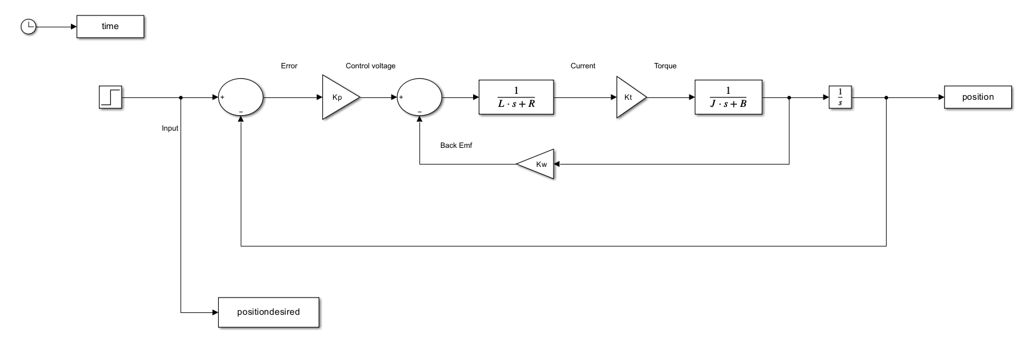

**Kp = 1**

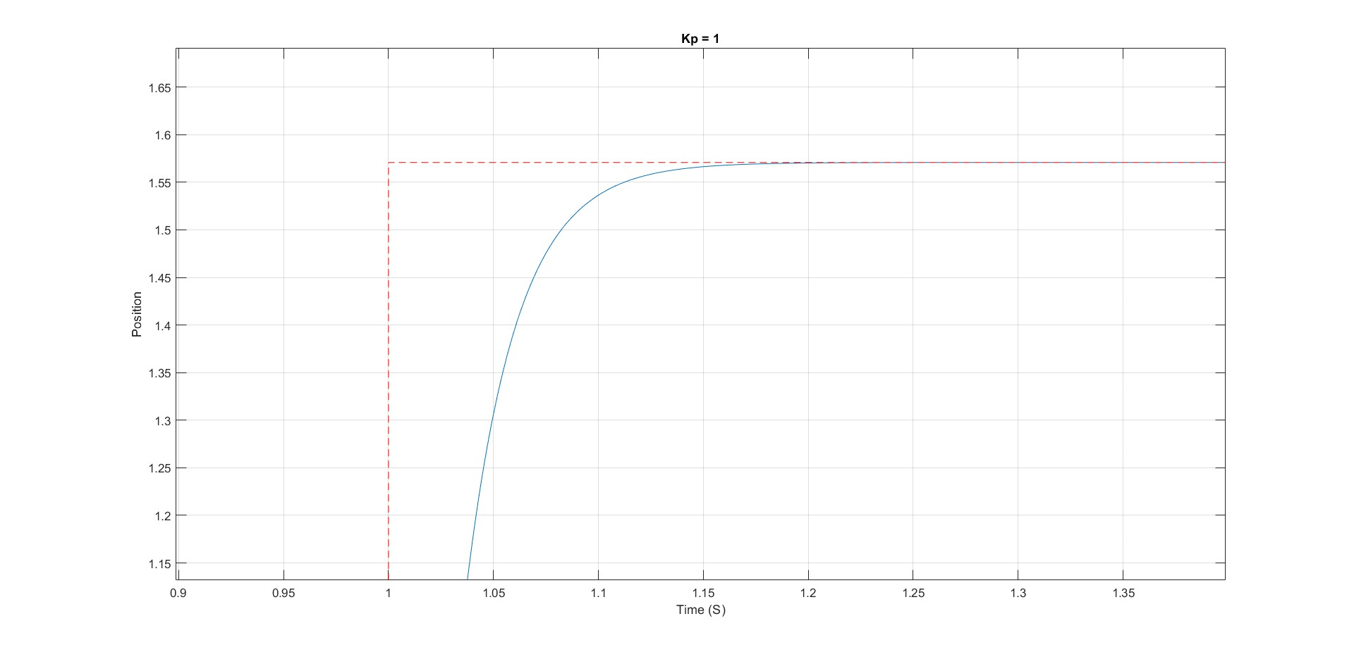

**Kp = 2**

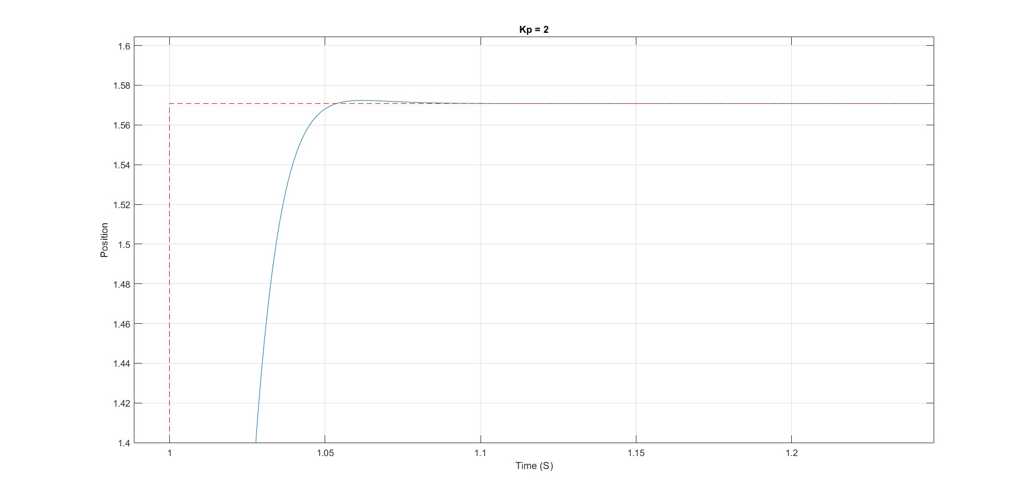

**Kp = 5**

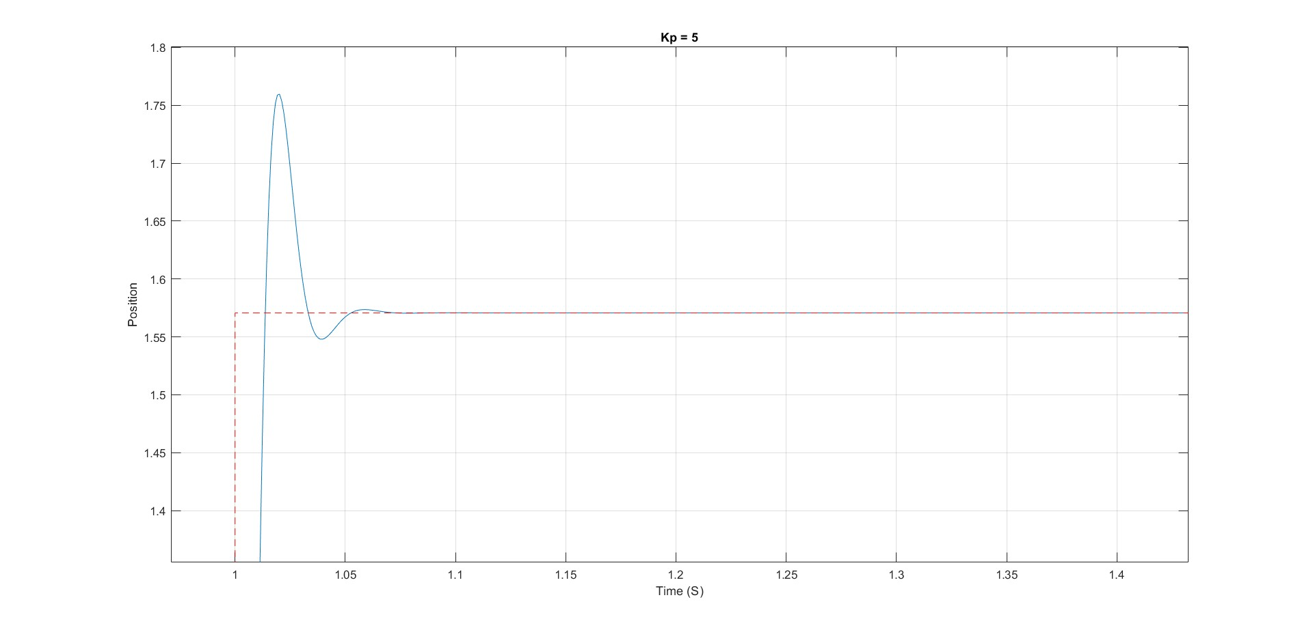

**Kp = 10**

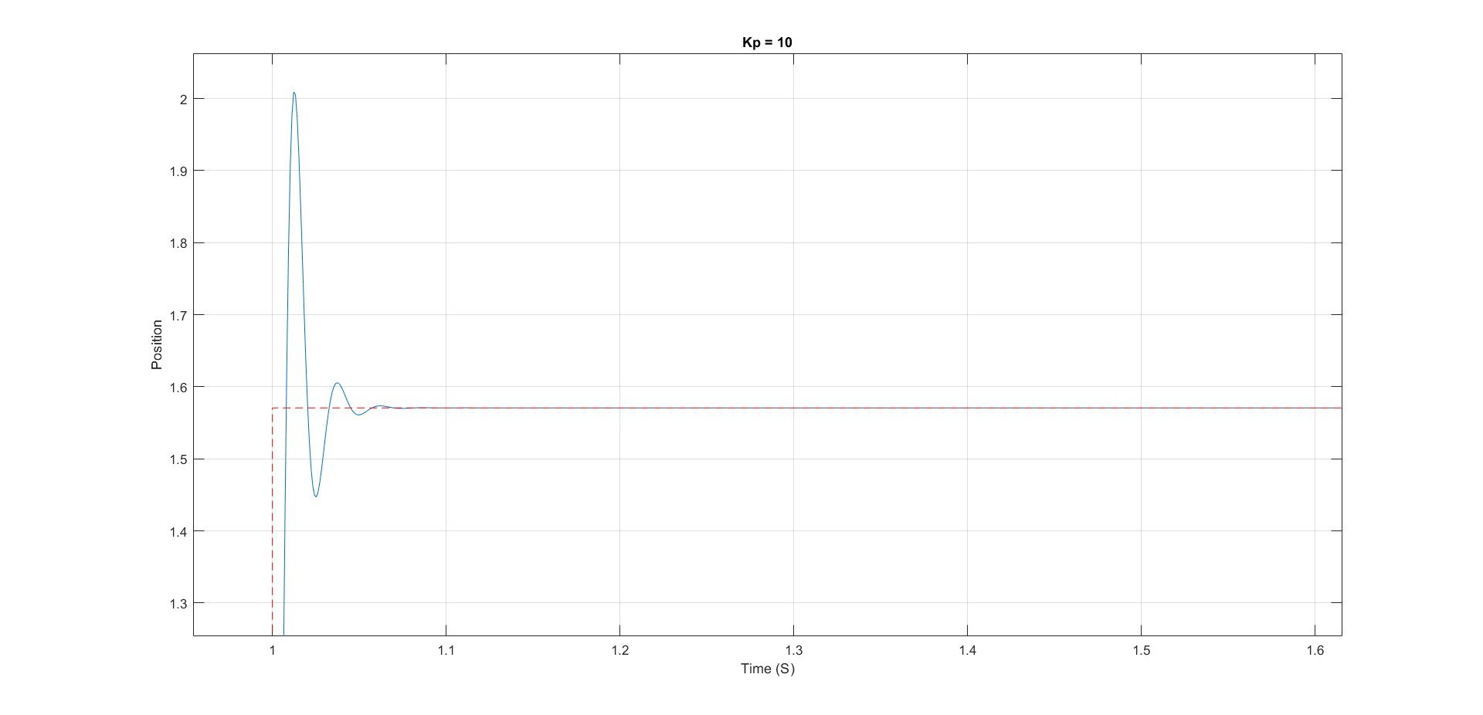

* 1. **Below is the Model with Sinusoidal Response**

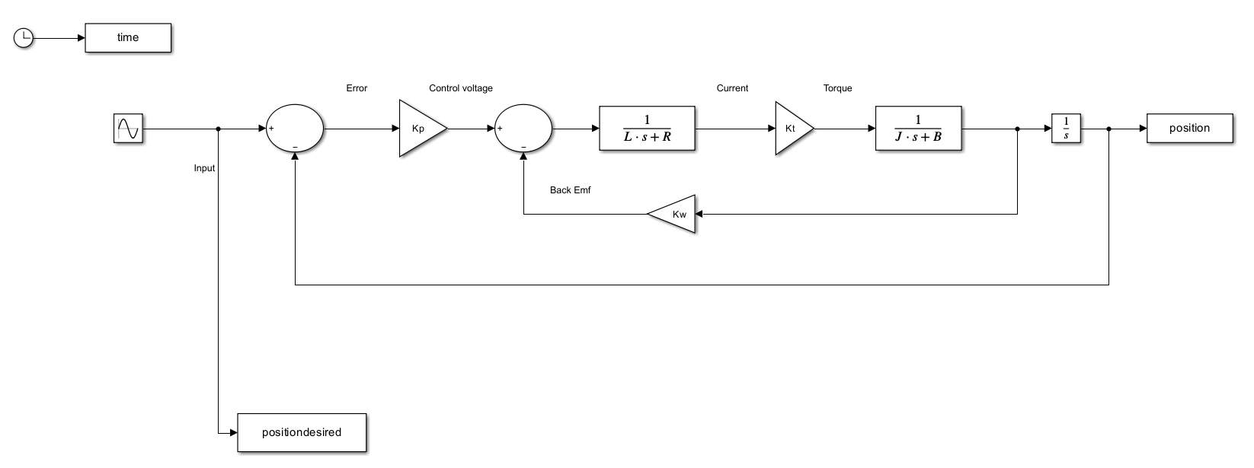

**Kp = 1**

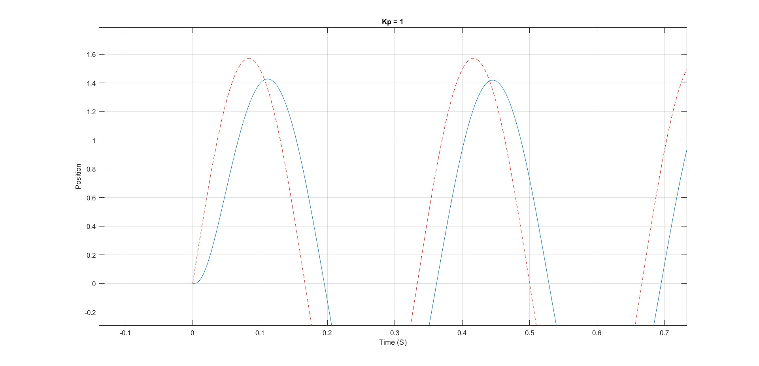

**Kp = 2**

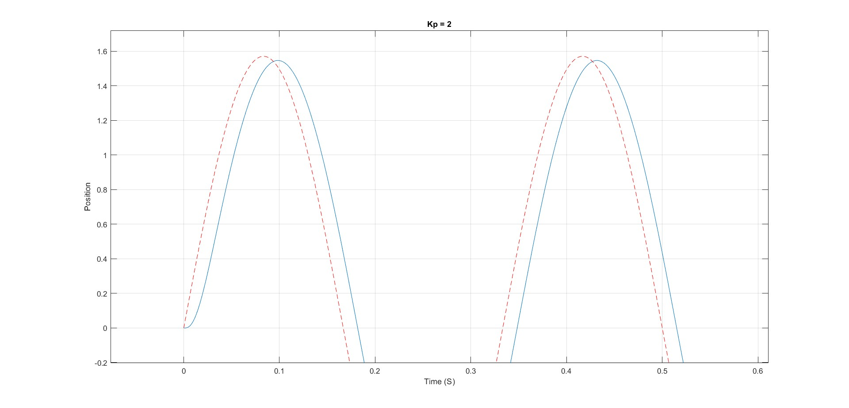

**Kp = 5**

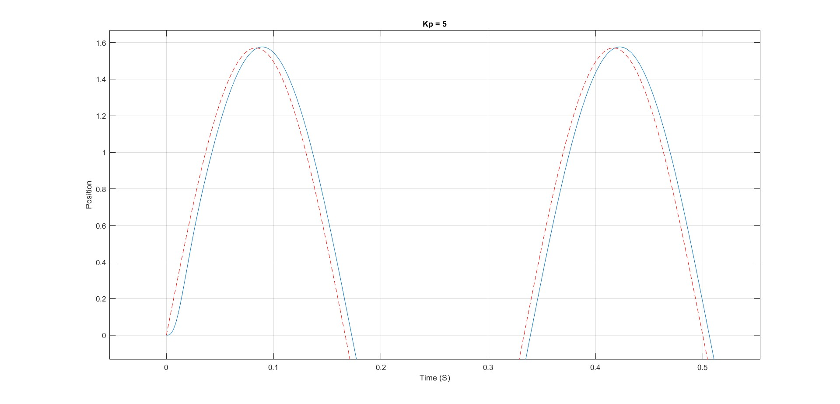

**Kp = 10**

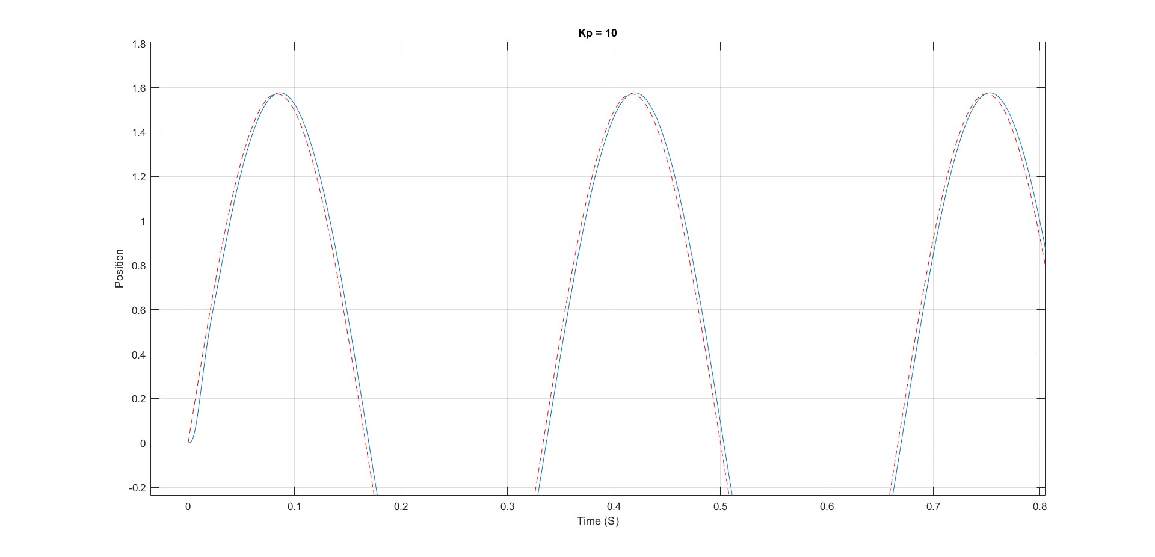

4. Develop a model with both Kp and Kd and make sure there is no overshoot

**The Step response with both Kp and Kd and has no overshoot**

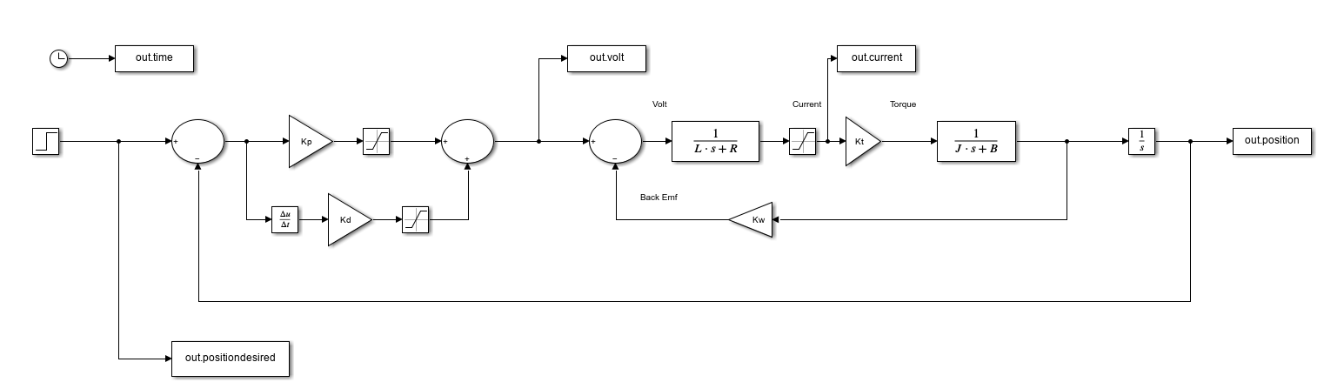

And the best **step response** for Kp = 1 and Kd = 0.0006

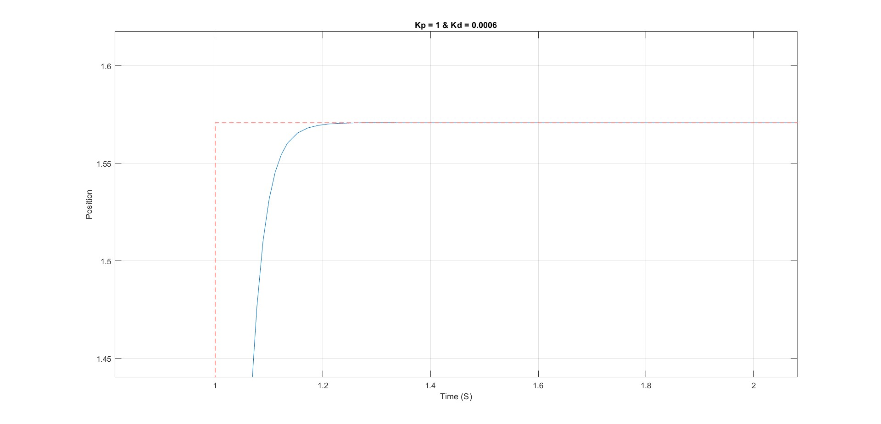

**The sinusoidal response with both Kp and Kd and has no overshoot**

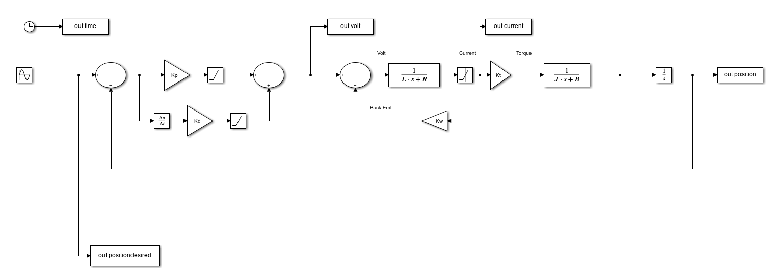

And the best **Sinusoidal response** for Kp = 5 and Kd = 0.0009